Graphs 5
AdjList with Cities
Pendleton Pueblo
Pensacola Phoenix
Peoria Pittsburgh
Peoria Pueblo
Phoenix Pittsburgh
Phoenix Pueblo
Pierre Pendleton
Pittsburgh Pensacola
Pittsburgh Phoenix
Princeton Pittsburgh
Princeton Princeton
Pueblo Pendleton
Pueblo Pierre

In the previous AdjList labs we hard-coded the vertices and edges in the driver. It would be nicer to read that data from a text file. First we will read the cities. Then we read the edges between the cities, in the format as shown at the right.

The graph is familiar:

5 Pittsburgh
6 Princeton
1 Pensacola
2 Peoria
7 Pueblo
3 Phoenix
4 Pierre
0 Pendleton

How many vertices are in this graph?____
How many edges are in this graph?____
Is every vertex reachable? Y/N If yes, then the graph is strongly connected.
If you recall, depthFirstSearch returned a string of reachable vertices from a given source.
List the reachable cities from Pendleton:
List the reachable cities from Pittsburgh:
isReachable
Assuming that you have a working depthFirstSearch, let’s use its results to answer specific city-to-city reachability questions. Write isReachable :

public boolean isReachable(String source, String target)
{

Assignment
In AdjList comment in and implement the EdgeListWithCities interface.

interface EdgeListWithCities
{
public void readData(String cities, String edges);
public int edgeCount();
public int vertexCount();
public boolean isReachable(String source, String target);
public boolean isStronglyConnected(); //return true if every vertex is
//reachable from every other vertex, otherwise false
}

Remember that we are still using a TreeMap:
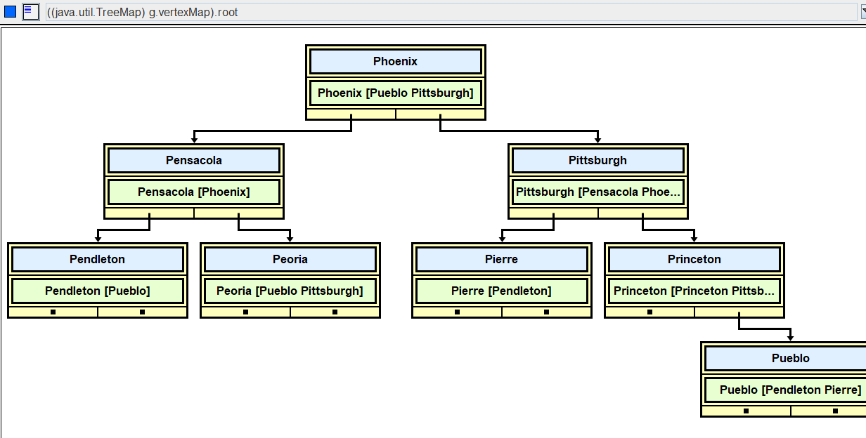

Write the three methods below.

public int edgeCount()
{

}

public int vertexCount()
{

}

//A directed graph is "strongly connected" if there is a directed
// path between every pair of vertices.
//@return true if every vertex is reachable from every
// other vertex, otherwise false
public boolean isStronglyConnected()
{

}

Sample Runs (AdjList_5_Driver with improved AdjList)

Edge List with Cities!  Enter file of cities: cities  Enter file of edges: cityEdges  The cities with their edges:  Pendleton [Pueblo]  Pensacola [Phoenix]  Peoria [Pueblo Pittsburgh]  Phoenix [Pueblo Pittsburgh]  Pierre [Pendleton]  Pittsburgh [Pensacola Phoenix]  Princeton [Princeton Pittsburgh]  Pueblo [Pendleton Pierre]  Number of vertices: 8  Number of edges: 13  Is this graph strongly connected? false  Can you get there from here?  Start at (-1 to exit): Pittsburgh  End at: Pueblo  true  Can you get there from here?  Start at (-1 to exit): Pueblo  End at: Pittsburgh  false  Can you get there from here?  Start at (-1 to exit): -1 | Edge List with Cities!  Enter file of cities: threeCities  Enter file of edges: threeCitiesEdges  The cities with their edges:  Pendleton [Pueblo]  Pierre [Pendleton]  Pueblo [Pendleton Pierre]  Number of vertices: 3  Number of edges: 4  Is this graph strongly connected? true  Can you get there from here?  Start at (-1 to exit): Pendleton  End at: Pierre  true  Can you get there from here?  Start at (-1 to exit): -1

